1. **Write a Java program to**

**a. Traverse nodes in a graph using breadth first search**

**import** java.io.*;

**import** java.util.*;

**public class** BFSTraversal

{

**private int** node;

**private** LinkedList<Integer> adj[]; **private** Queue<Integer> que; BFSTraversal(**int** v)

{

node = v;

adj = **new** LinkedList[node];

**for** (**int** i=0; i<v; i++)

{

adj[i] = **new** LinkedList<>();

}

que = **new** LinkedList<Integer>();

}

**void** insertEdge(**int** v,**int** w)

{

adj[v].add(w);

}

**void** BFS(**int** n)

{

**boolean** nodes[] = **new boolean**[node]; **int** a = 0; nodes[n]=**true**;

que.add(n);

**while** (que.size() != 0)

{

n = que.poll(); System.out.print(n+" ");

**for** (**int** i = 0; i < adj[n].size(); i++)

{

a = adj[n].get(i);

**if** (!nodes[a]) {

nodes[a] = **true**; que.add(a);

}

}

}

}

**public static void** main(String args[])

{

BFSTraversal graph = **new** BFSTraversal(6); graph.insertEdge(0, 1);

graph.insertEdge(0, 3);

graph.insertEdge(0, 4);

graph.insertEdge(4, 5);

graph.insertEdge(3, 5);

graph.insertEdge(1, 2);

graph.insertEdge(1, 0);

graph.insertEdge(2, 1);

graph.insertEdge(4, 1);

graph.insertEdge(3, 1);

graph.insertEdge(5, 4);

graph.insertEdge(5, 3);

System.out.println("Breadth First Traversal for the graph is:"); graph.BFS(0);

}

}

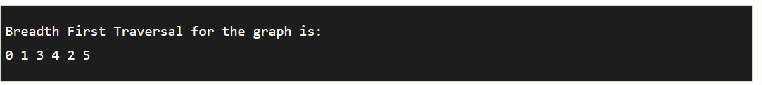

# Write a Java program to

**b. Implement circular queue**

import java.util.*;

public class prepinsta

{

int Queue[] = new int[100]; int n, front, rear;

public CircularQueue(int size)

{

n=size; front = 0;

rear=0;

}

public static void enqueue(int item)

{

if((rear+1) % n != front)

{

rear = (rear+1)%n;

Queue[rear] = item;

}

else

{

System.out.println(” No Insertion -Queue is full!”);

}

}

public static int dequeue()

{

int item;

if(front!=rear)

{

front = (front+1)%n;

item = Queue[front]; return item;

}

else

{

System.out.println(“Can’t remove element “);

}

}

public static void display()

{

int j;

if(front != rear)

{

for(j=(front+1)%n ; j<rear ; j=(j+1)%n)

{

System.out.println(Queue[j]);

}

}

else

System.out.println(“Queue is empty cant display!”);

}

public static void main(String args[])

{

System.out.print(“Size of queue : “); Scanner sc = new Scanner (System.in);

int size = sc.nextInt();

CircularQueue cq = new CircularQueue(size); System.out.println(” element in queue are “);

cq.enqueue(20); cq.enqueue(40); cq.enqueue(60); cq.enqueue(80); cq.display();

int data = cq.dequeue();

System.out.println(” element delete is “+data); System.out.println(” element in queue after deletion “); cq.display();

}

}

# Output:

elements in queue are 100100

30

10

50

element deleted is 30

elements in queue after deletion

10

50